Title: 18100004273 A Hierarchical Timed-Automata Evaluation Model for Resource Orchestration and Resilience in SDN-Enabled Computation-Centric 6G ISAC Networks

Comments and Suggestions for Authors
Review 1
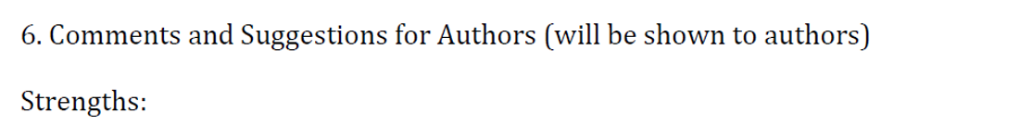
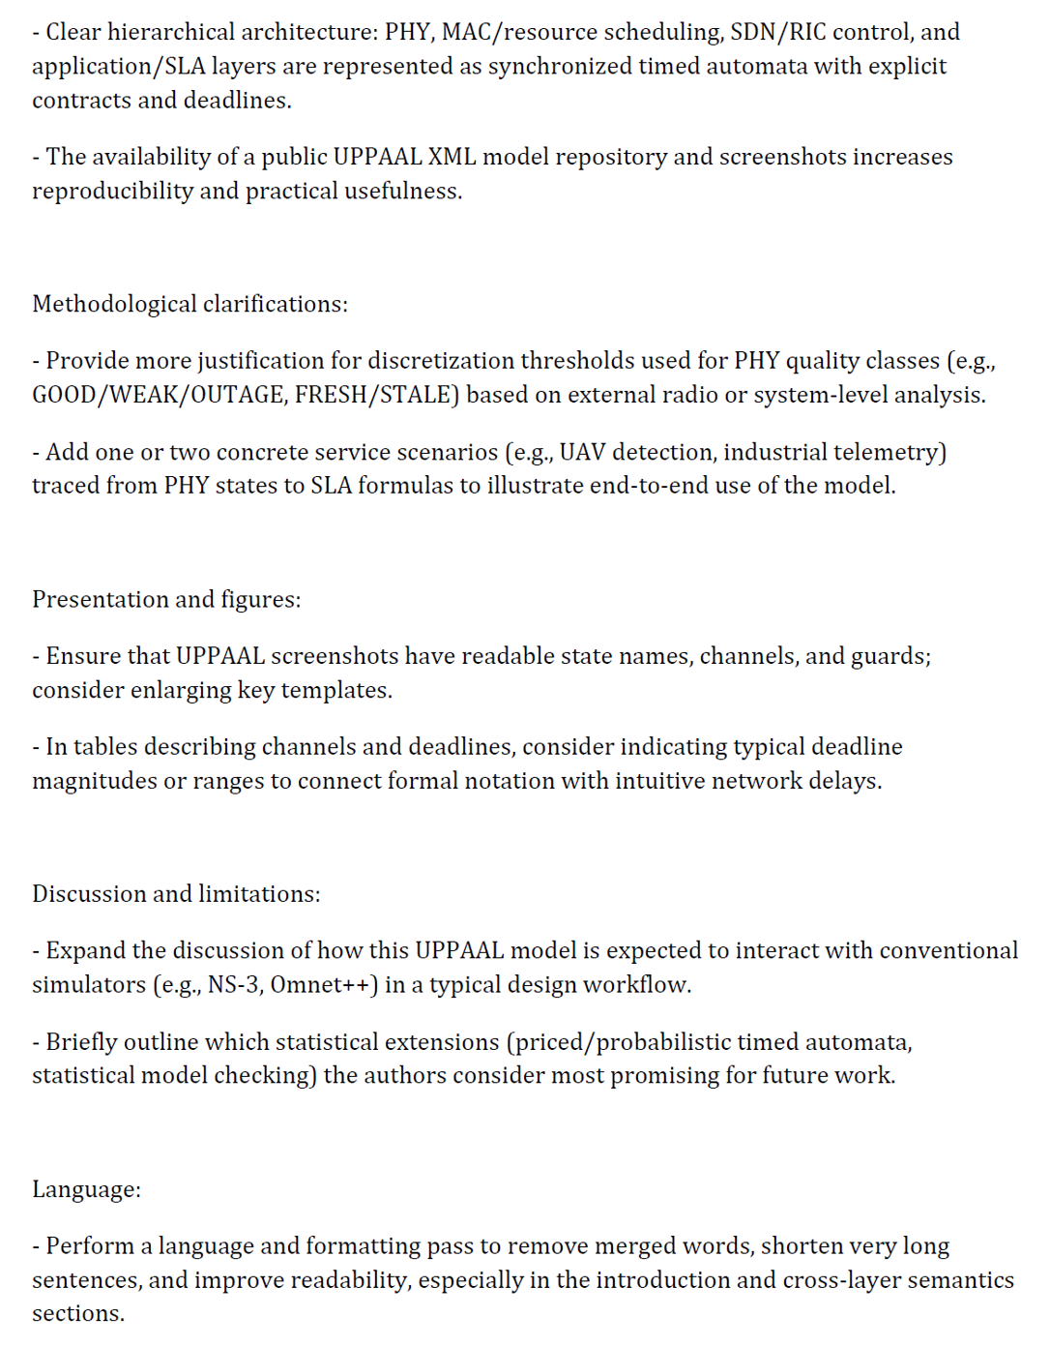
Review 2
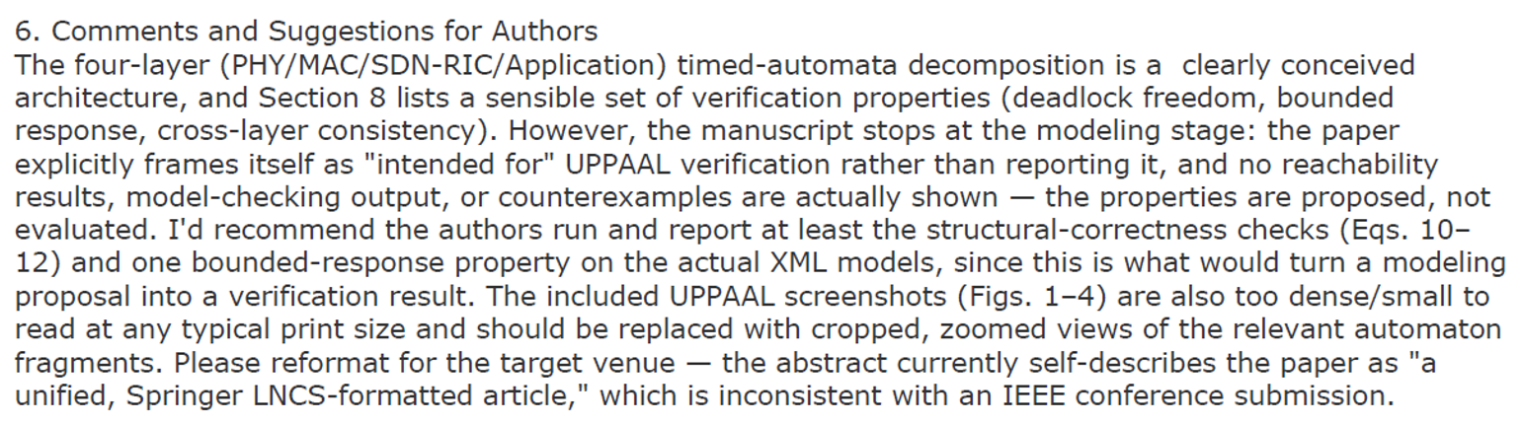
Review 3
